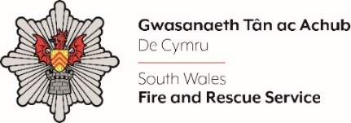
COMMUNITY SAFETY PRACTITIONER – REFLECT
Please complete the form below in FULL adhering to the 500-word limit for each of the shortlisting criteria (i.e. max of 1500 words). Then save in a Word document format and upload to the ‘supporting evidence’ section of the online application.

Please note that for shortlisting purposes we will be removing ‘Name’ and ‘National Insurance number’ and each candidate will be provided with a candidate number for anonymised shortlisting.

For any queries please contact recruitment@southwales-fire.gov.uk or for internal queries, please contact us via 24/7

Anonymised Candidate Number (to be completed by FRS HR team)
Question 1: Please outline your relevant experience of delivering youth work.

Question 2: Please provide evidence of your ability to communicate effectively both orally and in writing to a wide range of audiences.

Question 3: Please provide evidence of your ability to maintain a confident and resilient attitude in highly challenging situations.

Question 4: Please describe your experience of delivering presentations to a range of different audiences.

Question 5: Please outline your experience of effective and safe working practice within various environments.

Closing date – 12:00, midday on 1st September 2025

