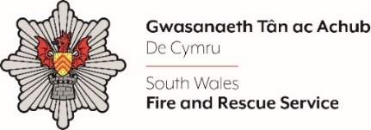
COMMUNICATIONS, ATTRACTION AND ENGAGEMENT OFFICER - 6 MONTH FTC

Please complete the form below in FULL adhering to the 500-word limit for each of the shortlisting criteria (i.e. max of 500 words). Then save in a Word document format and upload to the ‘supporting evidence’ section of the online application.

Please note that for shortlisting purposes we will be removing ‘Name’ and ‘National Insurance number’ and each candidate will be provided with a candidate number for anonymised shortlisting.

For any queries please contact recruitment@southwales-fire.gov.uk or for internal queries, please contact us via 24/7

Anonymised Candidate Number (to be completed by FRS HR team)
Question 1: In 500 words or less, please provide clear evidence that demonstrates how your experience aligns with the following essential criteria outlined in the job description:
- Educated to degree level and/or relevant experience within an associated field i.e., Engagement, Marketing, Public Relations, or Media Relations.
- A proven track record of proactively leading, coordinating and facilitating engagement and communications activities, including events.
- Experience of using a range of communications and engagement methods i.e., social media, events, media liaison, websites, intranet and hard copy documentation/resources.
- An understanding of promotional campaigns and all associated messaging.

Closing date – 12:00 Midday 25th August 2025

