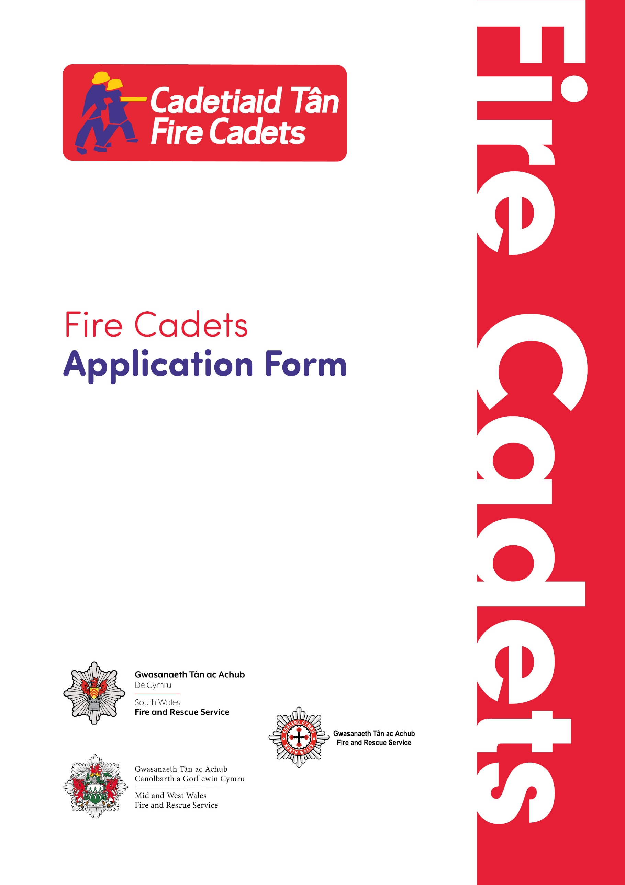

Please return by email: [FireCadets@southwales-fire.gov.uk](mailto:FireCadets@southwales-fire.gov.uk) or send printed application forms to:

South Wales Fire and Rescue Service Headquarters,  
Forest View Business Park, Llantrisant, Pontyclun, CF72 8LX.

**Closing date for applications: Monday 18th August**

**1. Young Person Details**

This form should be completed by the parent / guardian for any Young Person under the age of 18. If necessary, the form can be completed by a nominated scribe.

This next section is mandatory- Please complete all field criteria.

|  |  |  |  |  |  |  |  |  |  |  |  |  |  |  |  |  |
| --- | --- | --- | --- | --- | --- | --- | --- | --- | --- | --- | --- | --- | --- | --- | --- | --- |
| **Name of person filling out the form with legal responsibility for Young Person.** | | | | | | | | | | | | | | | |  |
| **Relationship to participant** (Parent, Guardian, Social Worker) | | | | | | | | | | | | | |  | | |
| **Participants legal name** (including any middle names) | | | | | | | | | | | | | |  | | |
| **Participants preferred name** (if different to the name above) | | | | | | | | | | | | | |  | | |
| **Address** (participant) | | | |  | | | | | | | | | | | | |
| **Postcode** |  | | | | | | | | | | | | | | | |
| **Participants Date of Birth** | | | | | | |  | | | | | | | | | |
| **Confirm age at application** (13-16 yrs) | | | | | | | | |  | | | | | | | |
| **Sex** (indicate with an ‘x’) | | | | |  | Female | | |  | | Male | |  | | Prefer not to say | |
| **Home Telephone** | | |  | | | | | | | | **Mobile** | | | |  | |
| **Primary Email** | |  | | | | | | | | | | | | | | |
| **Name of Emergency Contact 1** | | | | | | | |  | | | | | | | | |
| **Address** |  | | | | | | | | | | | | | | | |
| **Email** |  | | | | | | | | | | | | | | | |
| **Telephone** |  | | | | | | | | **Mobile** | | | |  | | | |
| **Name of Emergency Contact 2** | | | | | | | |  | | | | | | | | |
| **Address** |  | | | | | | | | | | | | | | | |
| **Email** |  | | | | | | | | | | | | | | | |
| **Telephone** |  | | | | | | | | | **Mobile** | |  | | | | |

**CONSENT:**

By signing this referral form you are confirming that you hold parental responsibility over the named child/young person, and you are consenting to South Wales Fire and Rescue Service (“SWFRS”) processing your and the child/young person’s personal data for the purposes of participating in the Fire Cadets.

|  |  |
| --- | --- |
| **Signatures** | |
| Parent/Guardian | |
| Signature |  |
| Print name |  |
| Date |  |

SWFRS is committed to protecting the data that we hold and processing it in accordance with data protection legislation. For further information on how we protect and process your information, please see our Privacy Notice (<https://www.southwales-fire.gov.uk/who-we-are/transparency/privacy-notice/>).

**2. Medical Information**

As a service we aim to be as inclusive as possible and can adjust our timetable / activities to accommodate requirements/conditions as necessary.

**Parent/Guardian must complete each section below and provide details as required.**

|  |  |  |  |
| --- | --- | --- | --- |
| **Does the applicant have any of the following?** | **Yes** | **No** | **Details** |
| **Allergies to medications** |  |  |  |
| **Food Allergies/Coeliac disease or special dietary requirements** |  |  |  |
| **Asthma** |  |  |  |
| **Epilepsy/seizures** |  |  |  |
| **Diabetes** |  |  |  |
| **Fainting or dizziness** |  |  |  |
| **Hayfever** |  |  |  |
| **Travel Sickness** |  |  |  |
| **Bone, muscle or joint conditions** |  |  |  |
| **Other condition** |  |  |  |
| **Details of any current medication, name and dosage** |  |  |  |
| **I consent to my child receiving medication as instructed and any emergency treatment including anaesthetic or blood transfusion as considered necessary by the medical authorities present.**  ***We would attempt to make contact with you before seeking treatment.*** |  |  |  |



|  |  |  |
| --- | --- | --- |
| **Additional Information** | **Yes** | **No** |
| **Does the Young Person present as Neurodiverse?** |  |  |
| **Are there any adjustments needed to support them?** (If ‘Yes’, please describe how below) |  |  |
|  | | |

**Young Person must complete each section below and provide details as required. (Parent/Guardian can scribe for young person if necessary.)**

|  |
| --- |
| **What interests you most about becoming a Fire Cadet?** |
|  |
| **How do you think being a Fire Cadet will help you develop personally?** |
|  |
| **Are you prepared to commit time regularly to training activities as part of**  **Fire Cadets to include charitable events and community engagement?** |
|  |
| **What hobbies and interests do you have currently?** |
|  |
| **Are you currently a member of any other clubs/youth groups?** |
|  |

**Our Commitment to You**

We understand that in some cases additional support may be needed to enable a candidate to participate fully in the Selection Process (e.g. dyslexia). Please record any support requirements that you may have in the space below. This information ****enables us to ensure that the necessary arrangements are made on your behalf. This detail is kept completely confidential and has no bearing on any selection decision.

|  |
| --- |
|  |

**3. Fire Cadets’ Code of Conduct**

Fire Cadet Instructors are responsible for maintaining appropriate conduct amongst Fire Cadets. Instructors, Volunteers and Cadets represent the Fire and Rescue Service (FRS) and must remember their responsibilities to the community, ensuring courteous and professional behaviour at all times.

**Listed below are the elements of the code of conduct to be followed by Instructors, and Cadets alike and will form an agreed contract when signed.**

• Fire Cadets and Instructors are required to act in a polite and disciplined manner and do nothing to bring the FRS into disrepute

• Parents/Carers are responsible for the Cadet’s safety when travelling to and from the Cadet location

• Cadets **must not** enter a Fire Station unsupervised nor arrive more than 30 minutes before the session begins. Instructors **must** be at the location prior to the Cadets arriving

• **All** uniform/PPE issued remains the property of the FRS and **must** be maintained in good condition and returned upon the request of the FRS

• Full uniform **must** be worn by all Cadets and Instructors when attending Fire Cadets sessions and official functions, and may **not** be worn on any occasion other than to official Fire Cadets activities

• All Fire Service equipment **must not** be operated unsupervised

• All personal property will be treated with respect

• Any damage or loss of uniform or equipment **must** be reported to an Instructor at the earliest opportunity

• Fire Cadets and Instructors **must** keep the premises clean and tidy at all times

• Smoking is **not permitted** during Fire Cadet Sessions or whilst undertaking Fire Cadet Activities

• Fire Cadets and Instructors are required to be presentable when in uniform. Long hair **must** be tied back and **must not** obscure the face in any way whilst on drill

• **No** visible jewellery should be worn during drill yard activities

• All accidents, injuries and near-misses occurring whilst undertaking Fire Cadet Activities **must** be reported immediately to Instructors and recorded appropriately in accordance with FRS procedures

• Fire Cadets **must** comply with all instructions given by Instructors

• Fire Cadets and Instructors **must** apply an attitude of fairness, equality and respect to others. Obscene or abusive language **will not** be tolerated

• Chewing gum is **not** permitted during Fire Cadet sessions or activities

• Personal mobile phones **must be turned off** and kept in a secure location during Fire Cadet sessions/activities. The FRS will not take any responsibility for personal belongings

• Fire Cadets who **do not follow** this code of conduct will be subject to the Fire Cadets’ Disciplinary Process

**I confirm that I have read and understand the code of conduct and agree to comply with all of the above.**

|  |  |
| --- | --- |
| **Signatures** | |
| Cadet (applicant) | |
| Signature |  |
| Print name |  |
| Date |  |
| **Signatures** | |
| Parent/Guardian | |
| Signature |  |
| Print name |  |
| Date |  |

**4. Equal Opportunities**

The Welsh Fire and Rescue Services are committed to offering equal opportunities. To monitor the effectiveness of our policy we would be grateful if you would answer the following questions. This information is confidential and used solely for monitoring purposes. 

|  |  |  |  |  |  |  |  |  |  |  |  |  |  |  |  |
| --- | --- | --- | --- | --- | --- | --- | --- | --- | --- | --- | --- | --- | --- | --- | --- |
| **Sex** (indicate with an ‘x’) | | | |  | Female | |  | | Male |  | Prefer not to answer | | | | |
| **Gender identity** | | | Is this the same as registered at birth? (indicate with an ‘x’) | | | | | | | | |  | Yes |  | No |
| If **’NO’** to the question above, please enter your gender identity below. | | | | | | | | | | | | | | | |
|  | | | | | | | | | | | | | | | |
| **Ethnic Origin** | | | | | | | | | | | | | | | |
| **Please note:** Ethnic Origin questions are not about nationality, place of birth or citizenship. They are about colour and broad ethnic group - UK citizens can belong to any of the groups indicated. (indicate your answer with an ‘x’) | | | | | | | | | | | | | | | |
| **Asian/ Asian British** |  | Bangladeshi | | | **Mixed** |  | | White & Black African | | | | | | | |
|  | Chinese | | |  | | White & Black Caribbean | | | | | | | |
|  | Indian | | |  | | White and Asian | | | | | | | |
|  | Pakistani | | |  | | Any other mixed background  (Please specify below) | | | | | | | |
|  | Any other Asian background | | |  | | | | | | | | | |
| **Black/ Black British** |  | African | | | **White** |  | | Welsh, English, Scottish, Northern Irish or British | | | | | | | |
|  | Caribbean | | |  | | Irish | | | | | | | |
|  | Any other Black background | | |  | | Gypsy or Irish Traveller | | | | | | | |
|  | | Any other White background  (Please specify below) | | | | | | | |
|  | | | | | | | | | |
|  | | | | | **Prefer not to answer** | | | | | | | | |  | |

|  |  |  |  |  |  |  |  |  |  |  |  |  |  |  |  |  |  |  |  |  |  |  |  |
| --- | --- | --- | --- | --- | --- | --- | --- | --- | --- | --- | --- | --- | --- | --- | --- | --- | --- | --- | --- | --- | --- | --- | --- |
| **Sexual Orientation** (indicate your answer with an ‘x’) | | | | | | | | | | | | | | | | | | | | | | | |
|  | Bisexual | | | |  | | Gay | | | | |  | | Lesbian | | | | |  | | Heterosexual | | |
|  | Prefer not to answer | | | | | | | | | | |  | | | | | | | | | | | |
| Any other Sexual Orientation (please specify below) | | | | | | | | | | | | | | | | | | | | | | | |
|  | | | | | | | | | | | | | | | | | | | | | | | |
| **Religion or Belief** (indicate your answer with an ‘x’) | | | | | | | | | | | | | | | | | | | | | | | |
|  | Buddhist | | |  | | Christian (all denominations) | | | | | | | | | |  | Hindu | | | | |  | Jewish |
|  | Sikh | | |  | | Muslim | | | | | | |  | | None | | | | |  | | Prefer not to answer | |
|  | Any other religion/belief (please specify) | | | | | | | | | | | | | |  | | | | | | | | |
| **Language – What is your main language?** (indicate your answer with an ‘x’) | | | | | | | | | | | | | | | | | | | | | | | |
|  | English | | |  | | Welsh | | | |  | Any other main language (Please specify below) | | | | | | | | | | | | |
|  | | | | | | | | | |  | | | | | | | | | | | | | |
| **Are you a Welsh speaker?** (indicate your answer with an ‘x’) | | | | | | | | | | | | | | | | | | | | | | | |
|  | No |  | Learner | | | | |  | Intermediate | | | | |  | Fluent | | |  | | | | | |
|  | Prefer not to say | | | | | | |  | | | | | | | | | | | | | | | |

**You are welcome to communicate with us in either English or Welsh.**

**Our paperwork is available in either English or Welsh.**