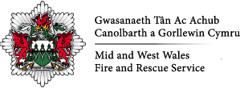 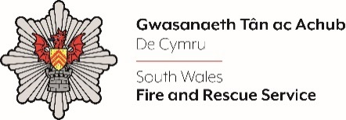

**999 Emergency Control Operator**

**If you are looking for a meaningful and purposeful job where you can help someone in their moment of need, apply to join the Fire and Rescue Services’ Joint Fire Control!**

**Salary**

**Fire Control Operator in Development - £28,865**

**Competent Fire Control Operator - £36,937**

Based in Bridgend, the Control Centre supports emergency calls and the mobilisation of resources and incident management for both Mid & West Wales and South Wales Fire & Rescue Services. The role provides an excellent opportunity to support the public and communities by answering and professionally handling 999 emergency calls, mobilising appliances, officers, and specialist resources to support the effective response to emergencies – no two calls are the same and no two days are the same!

**About the job**

We are looking for dedicated and enthusiastic Control Operators to work as part of our dynamic team to help support the 999 service and work to Fire and Rescue Service Values and standards of behaviour. You will need to be able to deal with distressed members of the public to gather appropriate and detailed information. Having excellent keyboard skills is vital for this job as you will need to record accurate information quickly at a minimum of 35 words per minute. You need to be highly professional, a strong listener with excellent communication skills and telephone manner. It is essential that you can follow processes and procedures and be able to remain calm under sustained pressure and work as part of a small teamTop of Form

.

***Please Note: The role of the control firefighter does not provide a career path to the role of wholetime or on-call firefighter. You will be required to serve in the role for a minimum of two years and be deemed competent before you will be eligible to apply for a Wholetime Firefighter Vacancy within Mid and West Wales Fire Service.***

**When will you work?**

The Control runs 24 hours a day, 7 days a week, and **all** rolling shift patterns will typically involve working a mixture of day and night shifts (including weekend shifts, Christmas and Bank Holidays).

**Applying for the role**

Applications are invited from Candidates with appropriate experience and qualifications in accordance with the Person Specification, which can be viewed in the Candidate Information Pack. Appointment to this role is subject to Police Vetting check. Before any formal offer of employment is made, candidates will be required to undergo a Drug and Alcohol Test.

A Candidate information pack is available to download from the Mid and West Wales Fire and Rescue Service or South Wales Fire and Rescue Service websites.

Application forms should be completed and returned via email to humanresources@mawwfire.gov.uk

Assessments for this role include ability tests, interviews and medicals. A timetable of assessments will be sent to successful candidates after the shortlisting stage. Further details of these tests can be found in the Candidate information pack.

**Please note:**

All staff members within the Fire Control Team are required to pass a South Wales Police vetting process prior to appointment (***Non Police Personnel Vetting (NPPV***). This level of vetting is standard practice and a requirement for anyone who has physical or remote access to police premises, information, or intelligence.

All documentation is available in both Welsh and English and we welcome correspondence in either. Applications submitted in Welsh will not be treated less favourably.

We believe in the true value of a diverse workforce and encourage applications from all sectors within the Community.

**Closing date**

22 August 2025