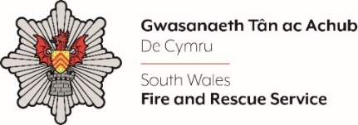
Deputy Chief Fire Officer

Shortlisting evidence Template

Please complete the form below in FULL adhering to the 500-word limit for each of the shortlisting criteria (i.e. max of 1500 words). Then save in a Word document format and upload to the ‘supporting evidence’ section of the online application.

Please note that for shortlisting purposes we will be removing ‘Name’ and ‘National Insurance number’ and each candidate will be provided with a candidate number for anonymised shortlisting.

For any queries please contact recruitment@southwales-fire.gov.uk or for internal queries, please contact us via 24/7

Anonymised Candidate Number (to be completed by FRS HR team)
Question 1: Personal Impact - Please outline how you have built trust and credibility at all levels to drive forward change and transformation.

Question 2: Outstanding Leadership – Please outline how you have developed high performing teams and driven up performance through a period of change and uncertainty.

Question 3: Service Delivery – Please outline how you have set a clear strategic direction in an organisation and how you engaged people in the journey

Question 4: Organisational Effectiveness – Please outline how you have taken steps to understand the effectiveness of an organisation and what steps you took thereafter.

Closing date – 2nd July 2025 12:00 Midday

