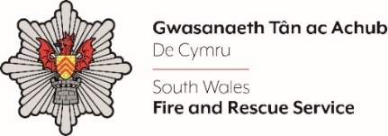
Employee Relations Business Partner

Shortlisting evidence Template

Please complete the form below in FULL adhering to the 500-word limit for each of the shortlisting criteria (i.e. max of 2000 words). Then save in a Word document format and upload to the ‘supporting evidence’ section of the online application.

Please note that for shortlisting purposes we will be removing ‘Name’ and ‘National Insurance number’ and each candidate will be provided with a candidate number for anonymised shortlisting.

For any queries please contact recruitment@southwales-fire.gov.uk or for internal queries, please contact us via 24/7

Anonymised Candidate Number (to be completed by FRS HR team)
Question 1: Please provide evidence of your ability to work collaboratively collectively effectively and efficiently with multiple stakeholders (internal and external)

Question 2: Please describe how you are forward-thinking and able to troubleshoot independently, with lots of initiative, energy and personal motivation

Question 3: Please explain how you have a proven track record of contributing to the delivery of multiple projects with conflicting priorities and varying stakeholder demands, whilst operating to tight deadlines

Question 4: Please outline how you meet or exceed the specialist qualifications and/or equivalent skills and experience as well as a passion, for taking the lead on the Employee Relations specialism.

Closing date – 20th June 2025

