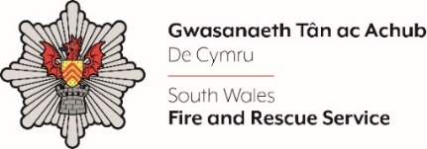
L&D Associate

Shortlisting evidence Template

Please complete the form below in FULL adhering to the 500-word limit for each of the shortlisting criteria (i.e. max of 2500 words). Then save in a Word document format and upload to the ‘supporting evidence’ section of the online application.

Please note that for shortlisting purposes we will be removing ‘Name’ and ‘National Insurance number’ and each candidate will be provided with a candidate number for anonymised shortlisting.

For any queries please contact recruitment@southwales-fire.gov.uk or for internal queries, please contact us via 24/7

Full Name:
National Insurance Number:
Anonymised Candidate Number (to be completed by FRS HR team)
Shortlisting Criteria 1: Please outline your experience of researching, creating, delivering and evaluating learning and development solutions and/or training packages.

Shortlisting Criteria 2: Provide an example of how you have worked with external providers or internal departments to develop effective organisational solutions.

Shortlisting Criteria 3: Can you evidence your proactivity in promoting change, and the ability to seek opportunities to promote improved organisational effectiveness.

Shortlisting Criteria 4: Can you share an example showing your ability to maintain a confident and resilient attitude in highly challenging situations.

Shortlisting Criteria 5: Can you outline your commitment to and ability to develop self, individuals and teams to enhance organisational effectiveness.

Closing date – 09/05/2025 by midday

