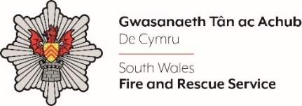
ICT Engineer – Service Desk

Shortlisting evidence Template

Please complete the form below in FULL adhering to the 500-word limit for each of the shortlisting criteria (i.e. max of 3000 words). Then save in a Word document format and upload to the ‘supporting evidence’ section of the online application.
Please note that for shortlisting purposes we will be removing ‘Name’ and ‘National Insurance number’ and each candidate will be provided with a candidate number for anonymised shortlisting.
For any queries please contact recruitment@southwales-fire.gov.uk or for internal queries, please contact us via 24/7

Full Name:
National Insurance Number:
Anonymised Candidate Number (to be completed by FRS HR team)
Question 1: Minimum HNC/HND or equivalent in ICT or relevant experience in an ICT environment.

Question 2: Experience in Service Desk/Technical Support environment, using service desk for ticketing and workflow management.

Question 3: Experience of administrating and first-line support for Microsoft 365 Technologies.

Question 4: A committed team player with the ability to communicate and work effectively within a team environment.

Question 5: Ability to communicate technical issues effectively both orally and in writing to a wide range of audiences
Question 6: Ability to understand and apply relevant information to make appropriate decisions which reflect key priorities and requirements to resolve technical issues efficiently
Closing date – 02/05/2025

