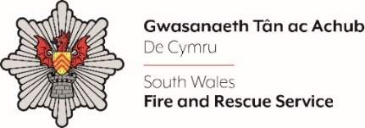
Learning & Development Manager
12 Month FTC

Please complete the form below in FULL adhering to the 500-word limit for each of the shortlisting criteria (i.e. max of 1500 words). Then save in a Word document format and upload to the ‘supporting evidence’ section of the online application.

Please note that for shortlisting purposes we will be removing ‘Name’ and ‘National Insurance number’ and each candidate will be provided with a candidate number for anonymised shortlisting.

For any queries please contact recruitment@southwales-fire.gov.uk or for internal queries, please contact us via 24/7

Full Name:
National Insurance Number:
Anonymised Candidate Number (to be completed by FRS HR team)
Shortlisting Criteria 1: Please outline your experience of designing and delivering leadership and management development programmes that have improved organisational effectiveness

Shortlisting Criteria 2: Please share an example of a time when you were able to quickly adapt and make an impact in a fast-paced environment, while taking initiative and working independently

Shortlisting Criteria 3: Please provide an example of when you have had to deliver multiple projects with conflicting priorities to meet varying stakeholder demands, whilst operating to tight deadlines

Shortlisting Criteria 4: Can you provide an example that demonstrates your ability to build strong relationships with stakeholders and effectively influence outcomes

Closing date – 18th March 2025

