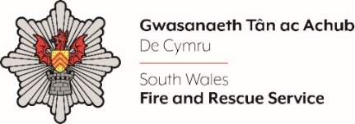
ASSISTANT CHIEF OFFICER
DIRECTOR OF SERVICE SUPPORT/ MONITORING OFFICER

Please complete the form below in FULL adhering to the 500-word limit for each of the shortlisting criteria (i.e. max of 1500 words). Then save in a Word document format and upload to the ‘supporting evidence’ section of the online application.

Please note that for shortlisting purposes we will be removing ‘Name’ and ‘National Insurance number’ and each candidate will be provided with a candidate number for anonymised shortlisting.

For any queries please contact recruitment@southwales-fire.gov.uk or for internal queries, please contact us via 24/7

Full Name:
National Insurance Number:
Anonymised Candidate Number (to be completed by FRS HR team)
Shortlisting Criteria 1: Eligibility: Please outline how you meet the essential qualifications and experience as set out in the Person Specification.

Shortlisting Criteria 2: Please tell us about your experience of effectively managing departmental and corporate budgets

Shortlisting Criteria 3: Please advise how you challenge executive decisions constructively and professionally in order to drive forward performance and improvement

Shortlisting Criteria 4: Please give an example of your ability to remain resilient and deliver high quality outputs when working to competing deadlines

Closing date – 18th March 2025

