Easy Read

South Wales Fire and Rescue Service
What we plan to do in 2021 to 2022.
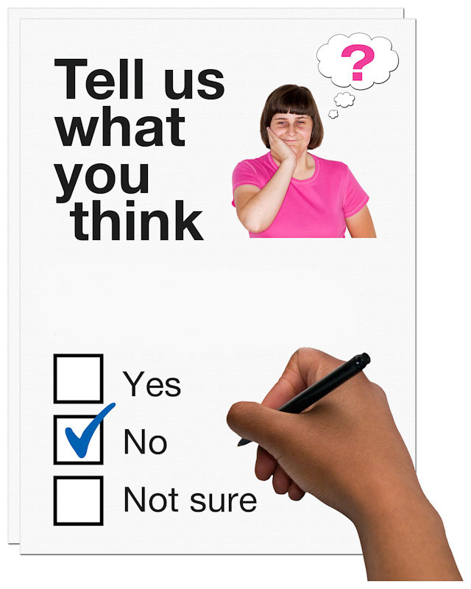
We want to know what you think

This document was written by South Wales Fire and Rescue Service. It is an easy read version of South Wales Fire and Rescue Service Annual Improvement Plan 2019-2020 survey.

November 2020

How to fill in this response form
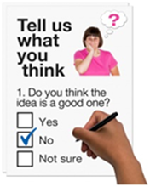 | These questions are about What we plan to do in 2021 to 2022.
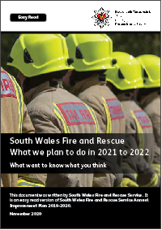 | Before you answer the questions, please read the main easy read document: South Wales Fire and Rescue Service - What we plan to do in 2021 to 2022
 | Some words may be hard to understand. They are in bold blue writing. You can find out what these words mean on page 20 of the main document.
 | Where the document says we, this means the South Wales Fire and Rescue Service.
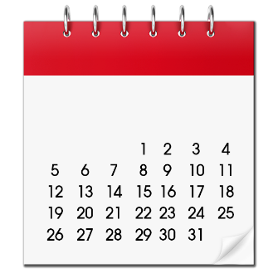 | Please send this form back to us by 15 January 2021.
By post:
Service, Performance & Communications Team
South Wales Fire and Rescue Service Headquarters
Forest View Business Park
Llantrisant
CF72 8LX
 | If you have any questions about this consultation, please contact us:
 | By email: HYS@southwales-fire.gov.uk
 | Or phone: 01443 232000
 | This form was made into easy read by Easy Read Wales using Photosymbols.

Questions
Keeping you safe
- Do you think it is important for us to work on these goals?

Our goals: | Yes | No | I do not know
Attend fewer calls that turn out to be false alarm calls | ☐ | ☐ | ☐
Make sure there are fewer fires and emergencies in homes and businesses | ☐ | ☐ | ☐
Make sure there are fewer traffic accidents | ☐ | ☐ | ☐
Have better safety in and around water | ☐ | ☐ | ☐
Have better fire safety in buildings and in our communities | ☐ | ☐ | ☐

Responding to your emergency
- Do you think it is important for us to work on these goals?
Our goals: | Yes | No | I do not know
Make sure we have enough Firefighters to help you | ☐ | ☐ | ☐
Make sure our Firefighters know what to do to help you | ☐ | ☐ | ☐
Make sure Firefighters have the right equipment to help you | ☐ | ☐ | ☐

Using technology well
- Do you think it is important for us to work on these goals?

Our goals: | Yes | No | I do not know
We want to have the best equipment to help in an emergency | ☐ | ☐ | ☐
We want to make sure our staff have the best equipment to support our Firefighters | ☐ | ☐ | ☐

Working with our partners
- Do you think it is important for us to work on these goals?

Our goals: | Yes | No | I do not know
Work with our Public Services Boards to support our communities | ☐ | ☐ | ☐
Work with other organisations to provide services when needed | ☐ | ☐ | ☐
Look at how we can work well with our partners. | ☐ | ☐ | ☐

Better communications
- Do you think it is important for us to work on these goals?

Our goals: | Yes | No | I do not know
Tell people about the work we do | ☐ | ☐ | ☐
Give people the chance to have their say | ☐ | ☐ | ☐
Keep our communities safe by talking to people at meetings and community events about fire safety | ☐ | ☐ | ☐

Valuing our people
- Do you think it is important for us to work on these goals?

Our goals: | Yes | No | I do not know
We want staff from diverse communities and backgrounds to work for us. | ☐ | ☐ | ☐
We want to help the people who work for us to feel happy and well at work. | ☐ | ☐ | ☐
We want to help people who work for us to have any training they need for their job. | ☐ | ☐ | ☐

Protecting our environment
- Do you think it is important for us to work on these goals?

Our goals: | Yes | No | I do not know
Reduce the use of things that can be used only once | ☐ | ☐ | ☐
Use electric vehicles if we can | ☐ | ☐ | ☐
Use less gas and electricity | ☐ | ☐ | ☐
Think about how our actions can affect the environment | ☐ | ☐ | ☐

Continuing to work effectively
- Do you think it is important for us to work on these goals?

Our goals: | Yes | No | I do not know
Open and honest with people about what we are doing | ☐ | ☐ | ☐
Making sure we are doing the best job we can to keep people safe | ☐ | ☐ | ☐
Only spend what we need to | ☐ | ☐ | ☐

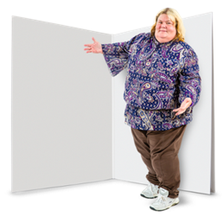 |  |  | Please use this space to tell us if:  - there is something you want to say about our goals for 2021 to 2022  - or if you think there is something else we should be working on.

Questions about you
 | We ask these questions because it helps us to understand the communities we are working with.
 | You do not have to answer any of these questions if you do not want to.
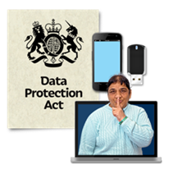 | We will keep your information safely. We will follow the laws about this.
 | If you want to know more about how we keep information safe, please email us at dataprotection@southwales-fire.gov.uk

More about you
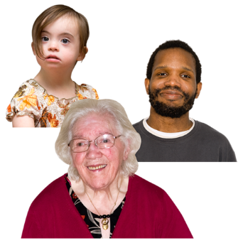
How old are you?
17 years old or younger | ☐
18 to 24 years old | ☐
25 to 34 years old | ☐
34 to 44 years old | ☐
45 to 54 years old | ☐
55 to 64 years old | ☐
65 to 74 years old | ☐
75 years old or older | ☐
I do not want to say | ☐

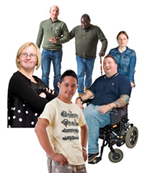 | Are you disabled?
 | Yes | ☐
 | No | ☐
 | I do not want to say | ☐
 | I prefer to think of myself as something else. Please tell us your own words:

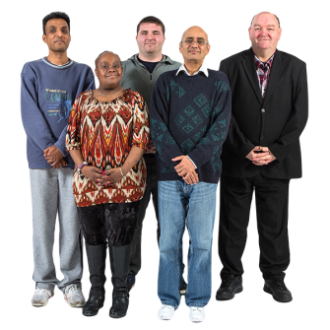 |  |  | Are you a:
 |  | Man |  | ☐
 |  | Woman |  | ☐
 |  | Trans |  | ☐
 |  | Trans is when you are called either a girl or a boy at birth, but you are the other.
 |  | Non-binary - I do not identify as male or female |  | ☐
 |  | I do not want to say |  | ☐
 |  | Or if you would like to use your own word please write it here:

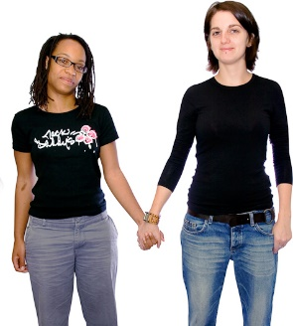 |  |  | Are you:
 |  | Bisexual |  |  |  |  | ☐
 |  | Gay/Lesbian |  |  |  |  | ☐
 |  | Straight |  |  |  |  | ☐
 |  | I do not want to say |  |  |  |  | ☐
 |  | Or if you would like to use your own word please write it here:
 |  |  |  | Your ethnicity
 |  |  |  | Asian | ☐
 |  |  |  | Black | ☐
 |  |  |  | Multi/Mixed | ☐
 |  |  |  | White | ☐
 |  |  |  | Other | ☐
 |  |  |  | I do not want to say | ☐
 |  |  |  | If you ticked other, please tell us what:

What is your religion or faith? Please tell us in the box below.
I do not want to say | ☐
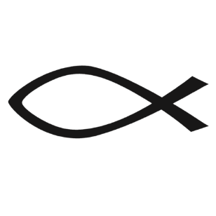
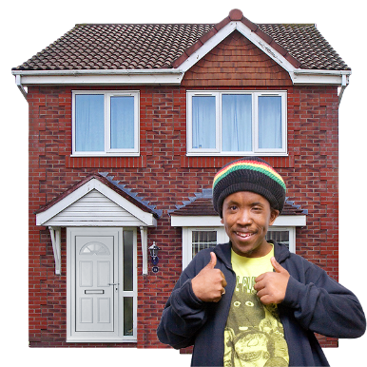
Where do you live? Please tell us in the box below.
I do not want to say | ☐

Thank you!

